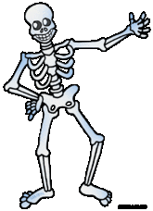**What are those bones?**

Cradle your **cranium,**

Munch with your **mandible,**

Clear along the **clavicle,**

Shrug your **scapulas,**

Tickle your **humerus** (it’s a funny bone!)

Rub your **rib cage**

Pat your **pelvis**

Rotate your **radius** beside your **ulna**

Wiggle the **phalanges** then …

Put those fingers on your **femur!**

Down on your **patellas,**

Stand up with your **fibula** and **tibia,**

Finally, **metatarsals** at the end of your feet!