 |  | Taking IDL – Human Body Outdoors Sequence Planner
The City of Edinburgh Outdoor Learning Team
Experiences and Outcomes:

By researching, I can describe the position and function of the skeleton and major organs of the human body and discuss what I need to do to keep them healthy.
SCN 1-12a
I have explored my senses and can discuss their reliability and limitations in responding to the environment.
SCN 1-12b

Benchmark | SCN 1-12a  Uses components to make simple models of a skeleton which identify the skull, spine, ribcage and some bones of the arms and leg and which show how the skeleton gives us support and protects our organs.  Structures a presentation or report, with support, on how to have a healthy lifestyle, for example, through a balanced diet, regular exercise, sufficient sleep and by avoiding substance misuse.  SCN 1-12b
  Uses their senses to detect information and explains how they help to keep people safe.
Core Aspect or Skill | The Human Body |  | Meta Skills | Collaboration  Curiosity
Key Questions

 | Learning Intention | Success Criteria | Activity (Indoor/ Outdoor) | Resources/ Links
Lesson 1 | We are learning about the human skeleton. | We will be able to name some bones in the human body.  We will be able to say where some bones are in the body. | Create a human skeleton using natural resources found in our playground. | 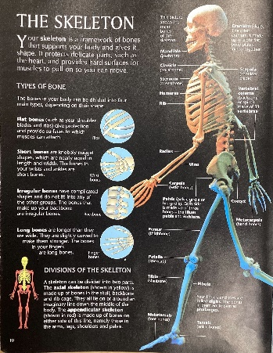  Prior classroom learning on the skeleton through literacy comprehension task. Design a poster using the information below.  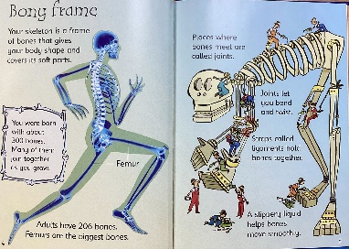
Lesson 2 | We are learning about the muscles in the human body and how we use them in exercise. | We will be able to identify which muscles we are using while exercising. | Outdoor circuit lesson  Pupils completed a strength / muscular endurance training circuit and had to identify the muscles they were working. | Station 1: Press ups  Station 2: Sit ups  Station 3: Tricep Dips  Station 4: Squats  Station 5: Calf Raises  Station 6: Wall sit
Lesson 3 | We are learning to use our senses to detect information. | We will be able to use our senses to detect information. | Senses outdoor scavenger hunt.  You can use the Go Find it Cards or the attached worksheet. | gofindit too The original outdoor nature scavenger hunt card game for kids and families Age 3+ Travel pocket game (Original) : Amazon.co.uk: Toys & Games  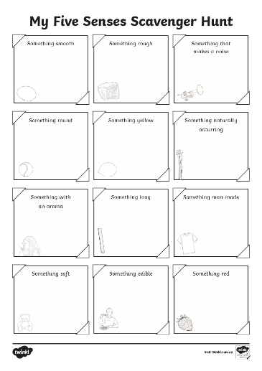
Lesson 4 | We are learning to use our senses to detect information. | We will be able to identify limitations to our senses when one is removed. | Blind folded obstacle course (night line)  Play a game of Marco Polo  Then split pupils into two groups if PSA available and lead them around playground ask them to guess where they are.  In two groups lead pupils through loose parts created obstacle course. | Blind folds  Loose parts resources

